Proof of Google Account

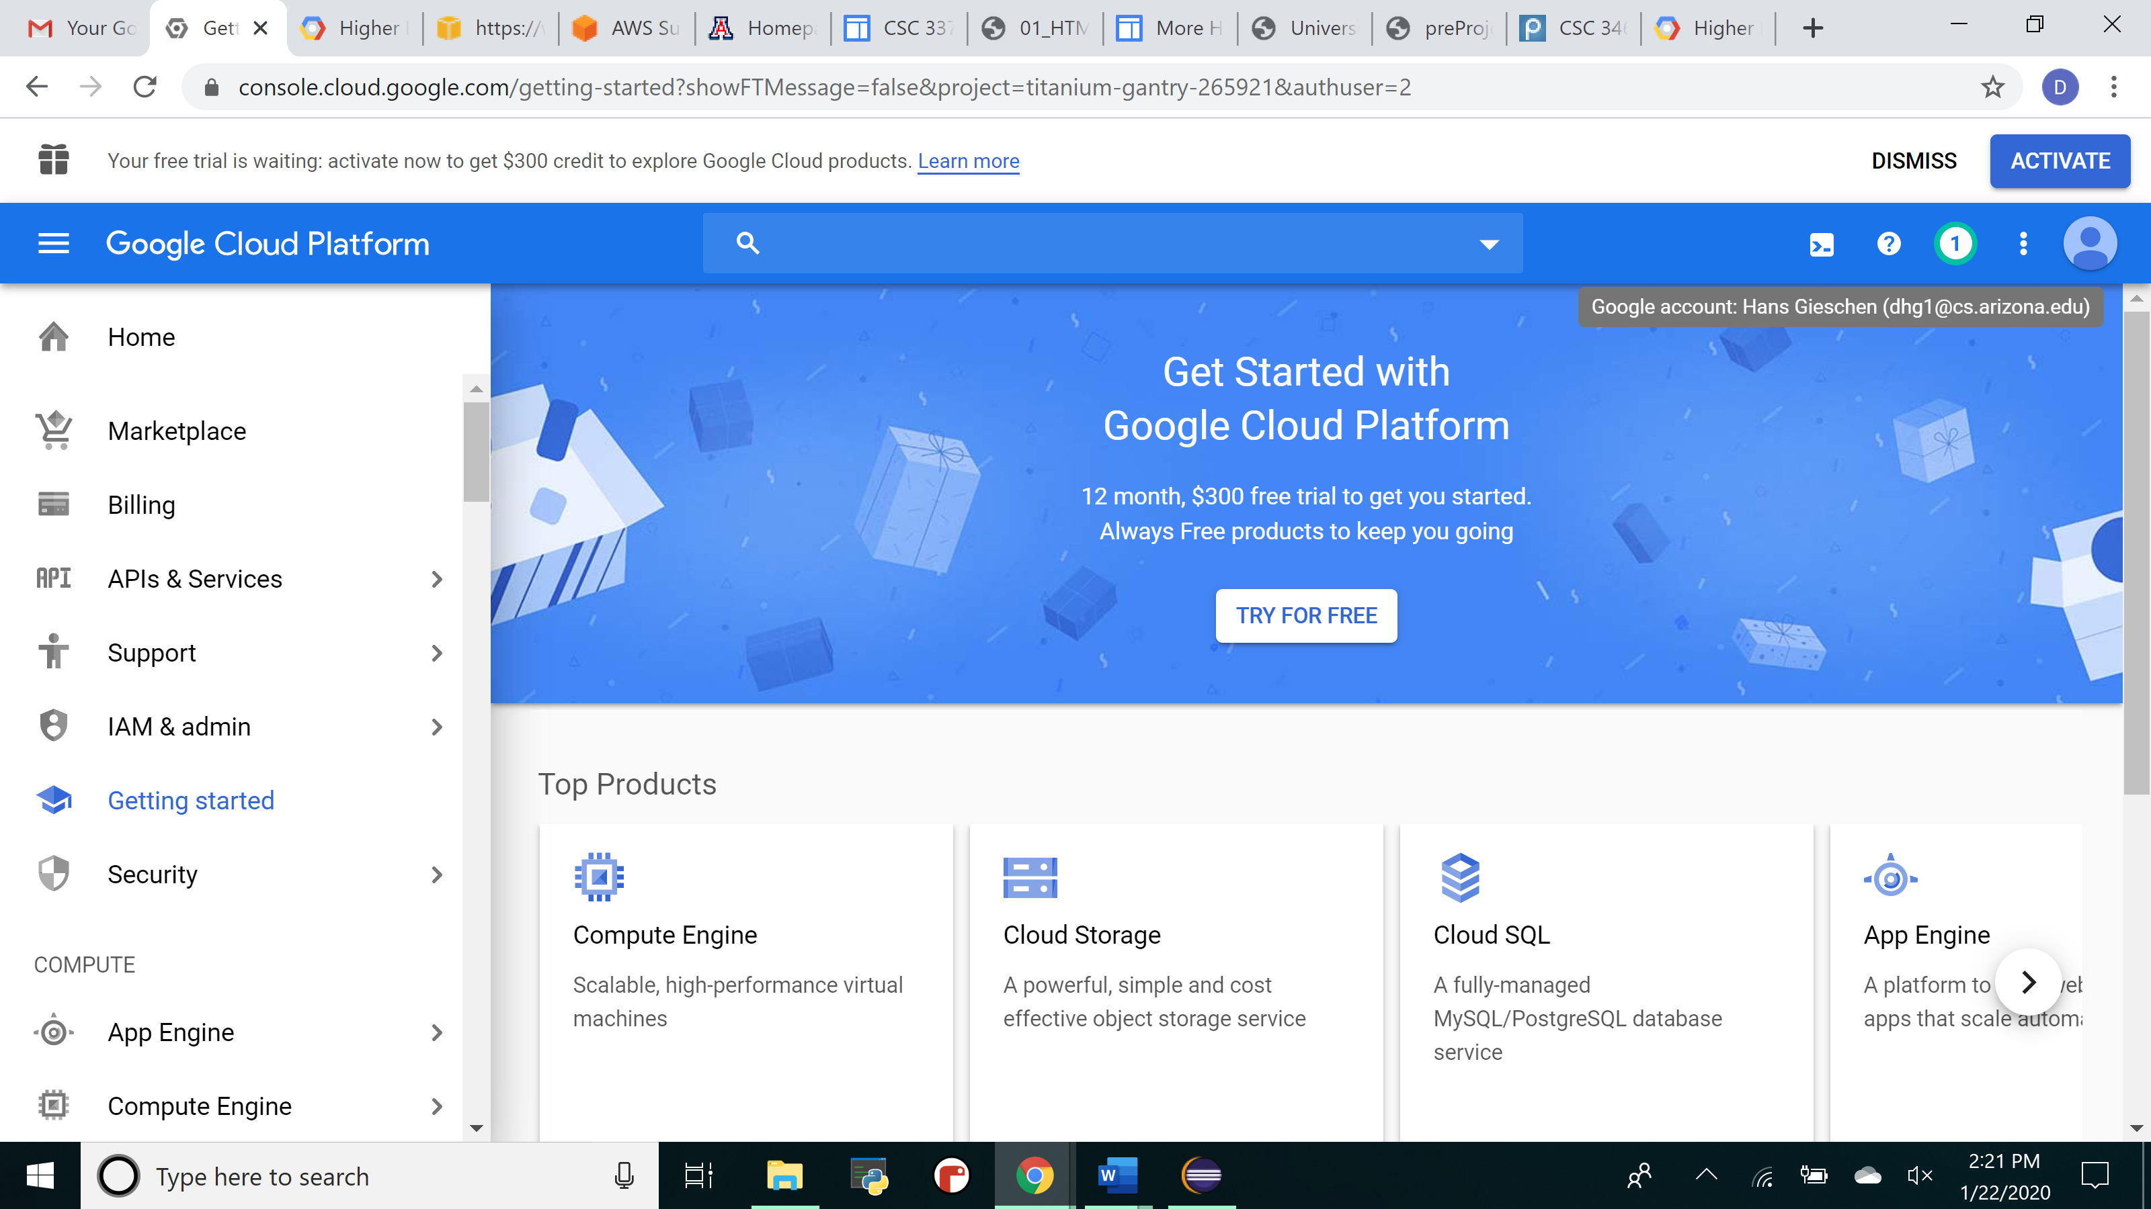

Proof of Dropbox account

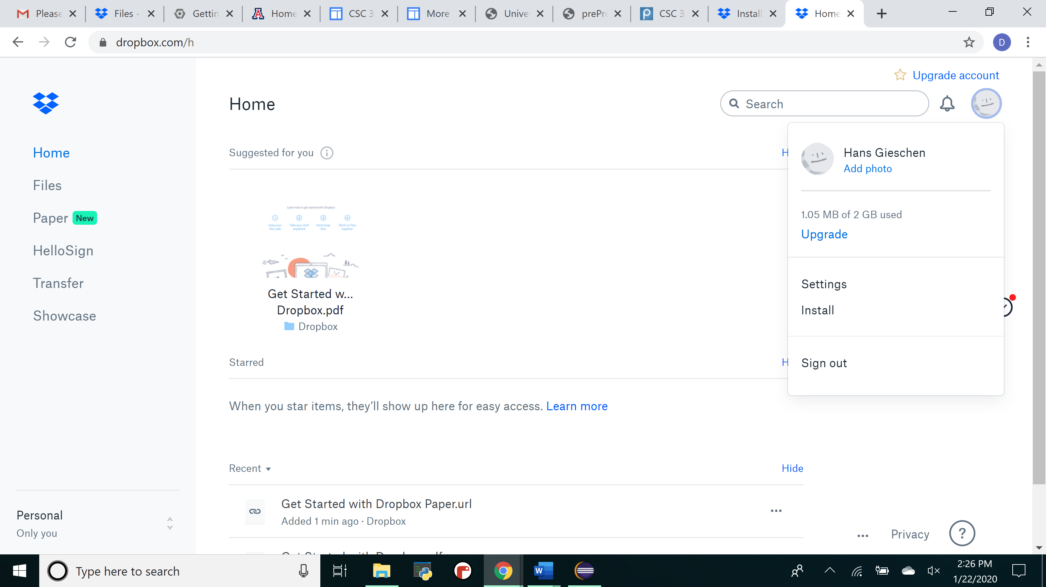

Applied for amazon web services but got rejected

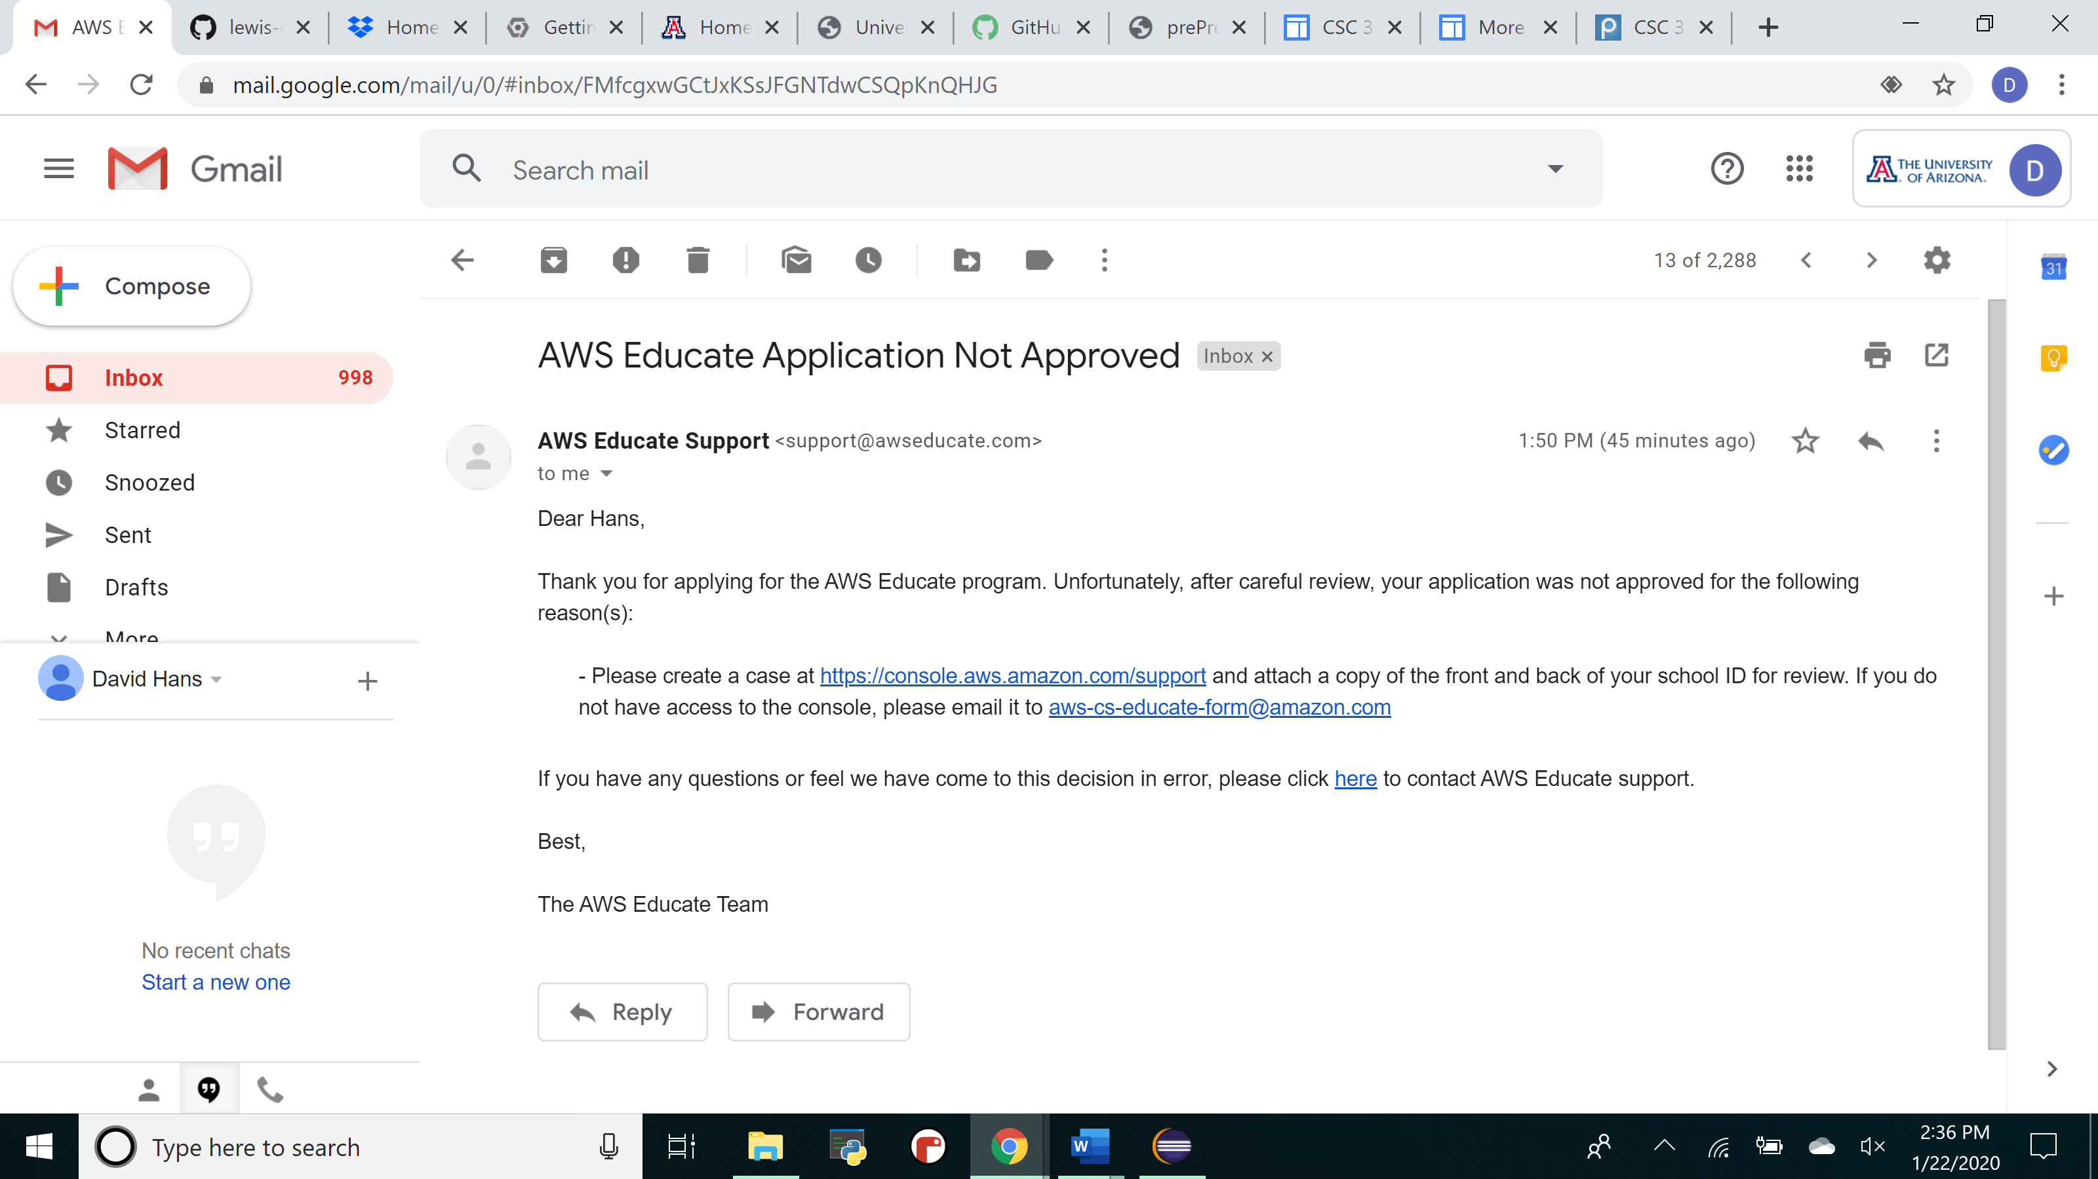

Contacted customer support and reapplied using my cs email to see either of those two routes would work.

